**Virtual Lecture Notes (Part 2)**

1. If you have not already created the Defining Static



Methods project in the Mod07 Lessons folder, please do so now.

2. Download the [**CylinderVolume**](https://www.connexus.com/extra/ThirdPartyProviders/FLVS/2394_2395_AP_CompSci_v9_CA/module07/javamod07/CylinderVolume.txt) class to the newly created project.

3. Examine the source code of the class, noting again the organizational structure, the modular division of labor into methods representing functional units with a single task, and the statements that invoke the methods within **main()**. Run the program and observe the output.

4. Try modifying this program by adding a method to calculate the area of a rectangle or a triangle.

**Testing Methods**

As you write more and more complicated programs, troubleshooting and debugging become more important. BlueJ provides a convenient way to check whether a method works, even if a program is incomplete.

Typically, when you right click on a class icon you want to run a program, so the highlighted option shown here is selected. This causes the main method to be executed and the program will either run correctly or generate a runtime error (doink).

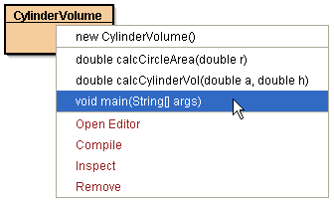

However, notice that if a program contains other methods, they are listed above the **main()** method.

The **CylinderVolume** class includes two methods (i.e., **calcCircleArea()** and **calcCylinderVol()** ) in addition to the **main()** method. Three important pieces of information are listed for each method: the return type, the name of the method, and the parameter list.

Clicking on the **caclCircleArea()** method opens the Method Call dialog box with a field to enter a value for the **r** parameter.

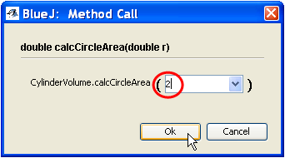

This allows you to type an appropriate value for **r** and see if the method works as intended.

In the example shown, the number 2 has been

entered. Pressing the Ok button will cause the method to execute.

The value entered is assigned to the parameter in the method header and then applied to the calculation to determine the area of a circle.

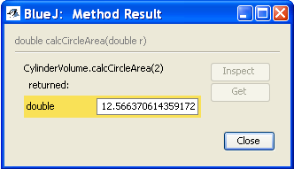

The resulting answer is printed in the Method

Result dialog box.

This is an extremely valuable tool for testing methods during the development process.

Check the **calcCylinderVol()** method in the same way. What could you enter to cause an error?